**-- FINAL CODE**

**-- Create tables**

CREATE TABLE

student (

rollno number PRIMARY KEY,

name varchar(40),

m_no varchar(10),

fine number,

issued_books number CHECK (issued_books <= 10)

);

**CREATE TABLE**

lib (

isbn number PRIMARY KEY,

bookname varchar(50),

author varchar(40),

publication varchar(20),

copies number,

lost_cost number,

delay_cost number

);

**CREATE TABLE**

book (

bookid number GENERATED BY DEFAULT ON NULL AS

IDENTITY PRIMARY KEY,

isbn number,

availability varchar(1) CHECK (

(availability = 'A')

OR (availability = 'O')

)

);

**CREATE TABLE**

subscription (

bookid number,

rollno number,

issue_date date,

return_date date,

actual_return_date date,

PRIMARY KEY (bookid, rollno)

);

**-- Add foreign keys now.**

ALTER TABLE book ADD CONSTRAINT book_fk FOREIGN KEY (isbn)

REFERENCES lib (isbn);

ALTER TABLE subscription ADD CONSTRAINT

subscription_fk_roll FOREIGN KEY (rollno)

REFERENCES student (rollno);

ALTER TABLE subscription ADD CONSTRAINT

subscription_fk_book FOREIGN KEY (bookid)

REFERENCES book (bookid);

**-- Insert some statements**

**-- 1.student**

INSERT INTO student VALUES (1, 'ALFRED', 623623623, 0, 0);

INSERT INTO student VALUES (2, 'JAMES', 659659659,0, 0);

INSERT INTO student VALUES (3, 'GEORGE', 654654654, 0, 0);

INSERT INTO student VALUES (4, 'TOM', 658658658,0, 0);

INSERT INTO student VALUES (5, 'PETER', 652652652,0, 0);

INSERT INTO student VALUES (6, 'JENNY', 651651651,0, 0);

INSERT INTO student VALUES (7, 'ROSE', 657657657,0, 0);

INSERT INTO student VALUES (8, 'MONICA', 639639639, 0, 0);

INSERT INTO student VALUES (9, 'PHOEBE', 678678678, 0, 0);

INSERT INTO student VALUES (10, 'RACHEL', 687687687,0, 0);

INSERT INTO student VALUES (11, 'ISHAAN', 9237463826,0, 0);

INSERT INTO student VALUES (12, 'CHIRAG', 8736482648,0, 0);

INSERT INTO student VALUES (13, 'SHRUTI', 5673927457,0, 0);

INSERT INTO student VALUES (14, 'NAVYA', 8693649274,0, 0);

INSERT INTO student VALUES (15, 'TANISHA', 9327561093,0, 0);

**Select * from student;**

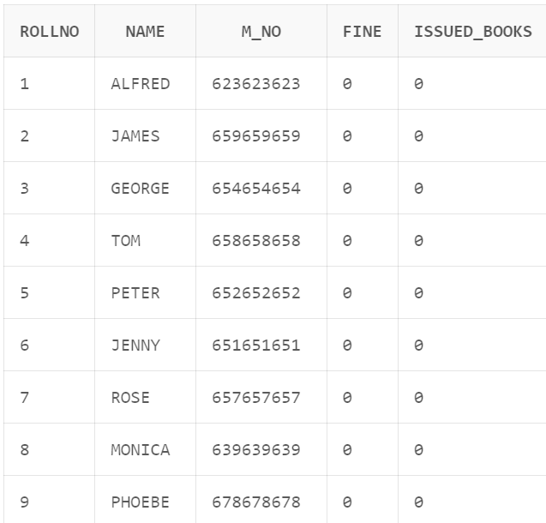

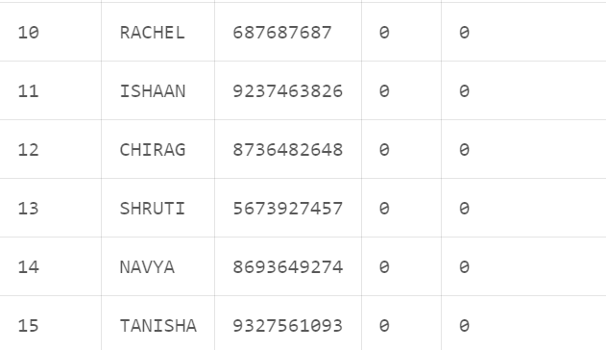

**-- 2.lib**

INSERT INTO lib VALUES(1200,'Lord Of Chaos', 'Robert Jordan','MacMillan', 1, 200, 1);

INSERT INTO lib VALUES(1201,'Fires Of Heaven', 'Robert Jordan','MacMillan', 11, 200, 1);

INSERT INTO lib VALUES(1202,'The Adventures of Tom Sawyer', 'Mark Twain','Sun India Publications', 5, 200, 1);

INSERT INTO lib VALUES(1203,'Treasure Island', 'Robert Louis Stevenson','Thakur Publications', 15, 200, 1);

INSERT INTO lib VALUES(1204,'Computer Networks', 'Saurabh Singhal','Cengage', 10, 200, 1);

INSERT INTO lib VALUES(1205,'.NET Framework & C#', 'Sharad Kumar Verma','Wiley', 20, 200, 1);

INSERT INTO lib VALUES(1206,'C programming', 'B. kernighan','Pearson', 18, 200, 1);

**SELECT * FROM lib;**

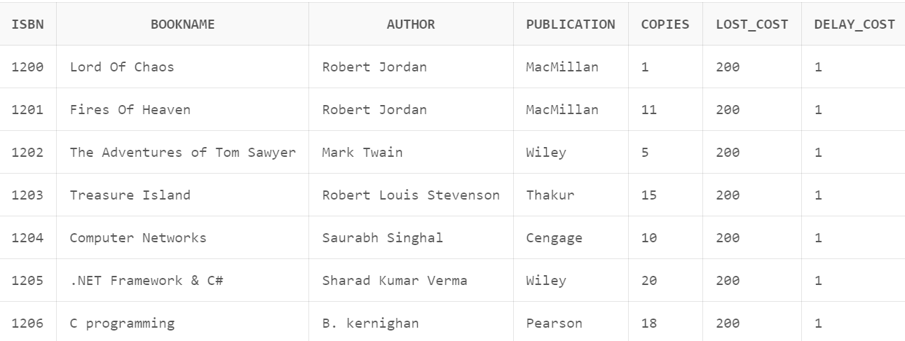

**-- 3.book**

INSERT INTO book VALUES(NULL, 1200, 'A');

INSERT INTO book VALUES(NULL, 1201, 'A');

INSERT INTO book VALUES(NULL, 1202, 'A');

INSERT INTO book VALUES(NULL, 1203, 'A');

INSERT INTO book VALUES(NULL, 1204, 'A');

INSERT INTO book VALUES(NULL, 1205, 'A');

**SELECT * FROM book;**

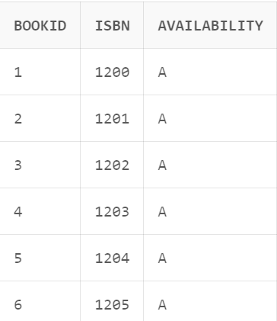

**-- 4.subscription**

INSERT INTO subscription VALUES(1,12,

to_date('01-04-2024','dd-mm-yyyy'),

to_date('27-04-2024','dd-mm-yyyy'),

to_date('01-05-2024','dd-mm-yyyy'));

INSERT INTO subscription VALUES(1,13,

to_date('01-02-2024','dd-mm-yyyy'),

to_date('27-03-2024','dd-mm-yyyy'),

to_date('01-03-2024','dd-mm-yyyy'));

INSERT INTO subscription VALUES(1,14,

to_date('27-04-2024','dd-mm-yyyy'),

to_date('28-05-2024','dd-mm-yyyy'),

to_date('27-05-2024','dd-mm-yyyy'));

**SELECT * FROM subscription;**

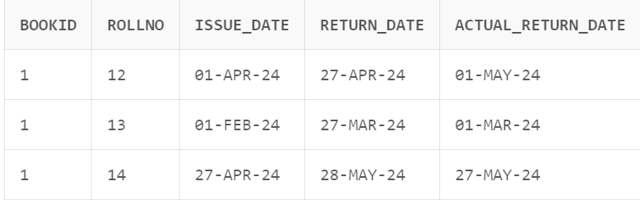

**-- Drop tables**

DROP TABLE student;

DROP TABLE subscription;

DROP TABLE lib;

DROP TABLE book;

**---------------------------------- plsql starts here -----------------------------------**

**-- *Procedure 1* --**

**-- Add students --**

CREATE OR REPLACE PROCEDURE add_student(roll_no in number,

s_name in varchar, m_no in varchar)

IS

BEGIN

INSERT INTO student VALUES(roll_no, s_name, m_no, 0,0);

END;

DECLARE

roll_no number;

name varchar(50);

m_no varchar(10);

BEGIN

roll_no := 16;

name := 'Shivankar';

m_no := '7006063825';

add_student(roll_no,name,m_no);

END;

**SELECT * FROM student;**

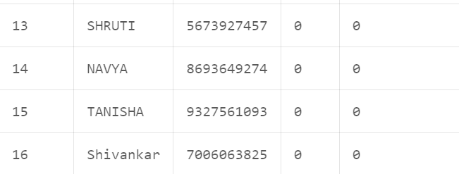 **// A new student added as roll no 16.**

**-- *Procedure 2* --**

**-- add first book/ more books --**

CREATE OR REPLACE PROCEDURE add_first_book(

isbn_no in number,

bookname in varchar,

author in varchar,

publication in varchar,

lost_cost in number,

delay_cost in number) IS

BEGIN

INSERT INTO lib VALUES(isbn_no, bookname,author,publication,

1,lost_cost, delay_cost);

INSERT INTO book VALUES(NULL, isbn_no, 'A');

END;

CREATE OR REPLACE PROCEDURE add_more_books(isbn_no in number) IS

BEGIN

INSERT INTO book VALUES(NULL, isbn_no, 'A');

UPDATE lib SET copies = copies + 1 WHERE lib.isbn = isbn_no;

END;

DECLARE

counter number;

isbn_no number;

bookname varchar(50);

author varchar(40);

publication varchar(20);

lost_cost number;

delay_cost number;

BEGIN

isbn_no := 1207;

SELECT count(*) INTO counter FROM lib WHERE lib.isbn = isbn_no;

IF counter > 0 THEN

add_more_books(isbn_no);

ELSE

bookname := 'Game of thrones';

author := 'Rishabh';

publication := 'Wiley';

lost_cost := 300;

delay_cost := 2;

add_first_book(isbn_no,bookname,author,publication,

lost_cost,delay_cost);

END IF;

END;

**SELECT * FROM lib;**

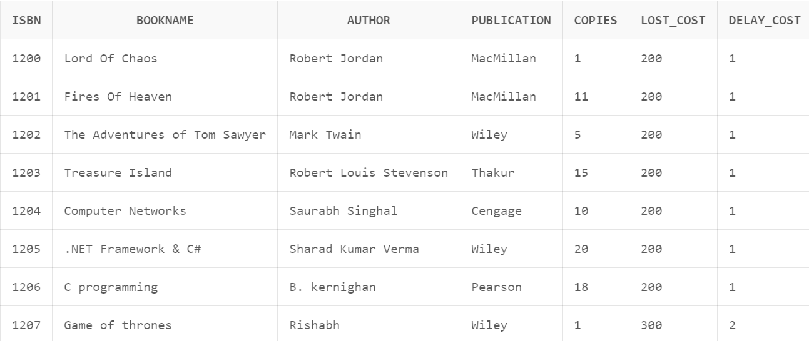

**// book with ISBN 1207 is not present so it get added with mentioned attributes.**

**-- *Procedure 3* --**

**-- issue a book --**

CREATE OR REPLACE PROCEDURE issue_book(

roll_no in number, book_id in number, issue_date in date) IS

isbn_no number;

BEGIN

UPDATE student SET issued_books = issued_books+1

WHERE rollno = roll_no;

SELECT isbn INTO isbn_no FROM book WHERE bookid = book_id;

UPDATE lib SET copies = copies - 1 WHERE isbn = isbn_no;

UPDATE book SET availability = 'O' WHERE bookid = book_id;

INSERT INTO subscription VALUES (book_id,roll_no,issue_date,

issue_date + 30,NULL);

END;

DECLARE

roll_no number;

book_id number;

i_date varchar(15);

issue_date date;

BEGIN

roll_no := 16;

book_id := 4;

i_date := '2024-04-27';

issue_date := to_date(i_date, 'yyyy-mm-dd');

issue_book(roll_no,book_id,issue_date);

END;

**SELECT * FROM subscription;**

**SELECT * FROM lib;**

**SELECT * FROM book;**

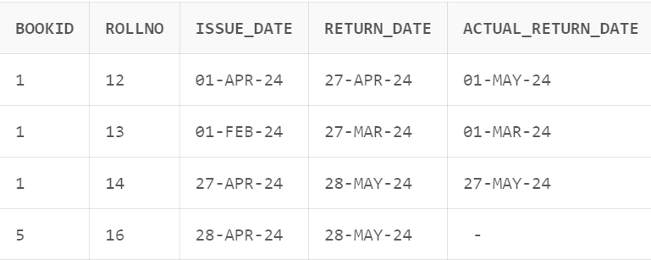 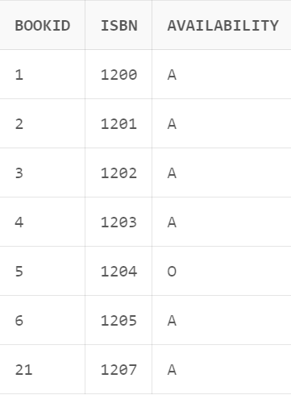

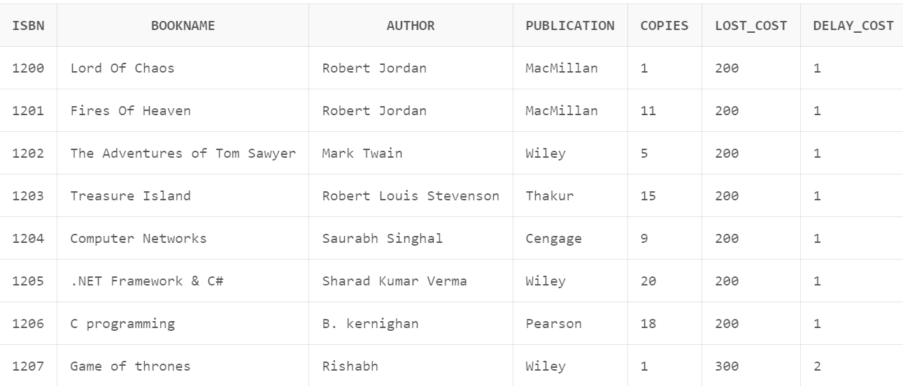

**-- *Procedure 4* --**

**-- return book --**

CREATE OR REPLACE PROCEDURE return_book(

book_id number, roll_no number) IS

i_date date;

r_date date;

ar_date date;

isbn_no number;

d_cost number;

no_of_copies number;

fine_amount number;

BEGIN

SELECT isbn INTO isbn_no FROM book WHERE bookid = book_id;

SELECT copies, delay_cost INTO no_of_copies, d_cost FROM lib

WHERE isbn = isbn_no;

no_of_copies := no_of_copies + 1;

UPDATE book SET availability = 'A' WHERE bookid = book_id;

UPDATE lib SET copies = no_of_copies WHERE isbn = isbn_no;

SELECT issue_date, return_date, actual_return_date INTO i_date, r_date,

ar_date FROM subscription WHERE bookid = book_id AND rollno = roll_no;

IF ar_date > r_date THEN

fine_amount := (ar_date - r_date) * d_cost;

UPDATE student SET fine = fine_amount WHERE rollno = roll_no;

dbms_output.put_line('Fine amount: ' || fine_amount);

END IF;

UPDATE student SET issued_books = issued_books - 1 WHERE rollno = roll_no;

--DELETE FROM subscription WHERE bookid = book_id AND rollno = roll_no;

END;

DECLARE

book_id number;

roll_no number;

r_date varchar(15);

ret_date date;

BEGIN

book_id := 4;

roll_no := 16;

r_date := '2024-07-02';

ret_date := to_date(r_date, 'yyyy-mm-dd');

UPDATE subscription SET actual_return_date = ret_date

WHERE rollno = roll_no

AND book_id = bookid;

return_book(book_id,roll_no);

END;

**SELECT * FROM student;**

**SELECT * FROM subscription;**

**SELECT * FROM lib;**

**SELECT * FROM book;**

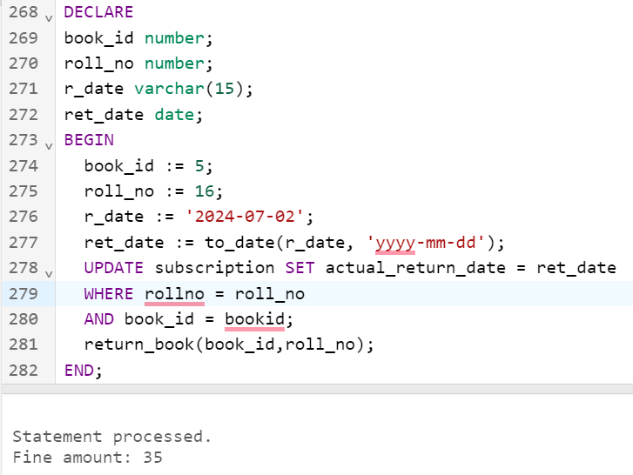 **// Fine generated due to late return of the book .**

**-- *Procedure 5* --**

**-- pay fine --**

CREATE OR REPLACE PROCEDURE pay_fine(roll_no number) IS

BEGIN

UPDATE student SET fine = 0 WHERE rollno = roll_no;

END;

DECLARE

rollno number;

BEGIN

rollno := 16;

pay_fine(rollno);

END;

**SELECT * FROM student;**

**-- *Procedure 6* --**

**-- BOOK INFO --**

CREATE OR REPLACE PROCEDURE book_info(i_sbn IN NUMBER) IS

c_opies lib.copies%TYPE;

d_elay_cost lib.delay_cost%TYPE;

b_ook_name lib.bookname%TYPE;

l_ost_cost lib.lost_cost%TYPE;

p_ublisher lib.publication%TYPE;

a_uthor lib.author%TYPE;

BEGIN

SELECT copies, delay_cost, bookname, lost_cost, publication, author

INTO c_opies, d_elay_cost, b_ook_name, l_ost_cost, p_ublisher, a_uthor

FROM lib

WHERE lib.isbn = i_sbn;

dbms_output.put_line('Copies : '||c_opies);

dbms_output.put_line('delay_cost : '||d_elay_cost);

dbms_output.put_line('book_name : '||b_ook_name);

dbms_output.put_line('lost_cost : '||l_ost_cost);

dbms_output.put_line('publisher : '||p_ublisher);

dbms_output.put_line('author : '||a_uthor);

END;

DECLARE

i_sbn number;

BEGIN

dbms_output.put_line('Enter the book number');

i_sbn:=1201;

book_info(i_sbn);

END;

**-- *Procedure 7* --**

**-- similar_author_books**

CREATE OR REPLACE PROCEDURE similar_author_books(auth in varchar)

AS

TEMP varchar(300);

CURSOR c1 IS SELECT bookname FROM lib WHERE author = auth;

rec varchar(300);

BEGIN

FOR rec in c1 LOOP

dbms_output.put_line(rec.bookname);

END LOOP;

END;

-- Exec similar_author_books('BookName')

DECLARE

author varchar(40);

BEGIN

author := 'Robert Jordan';

similar_author_books(author);

END;

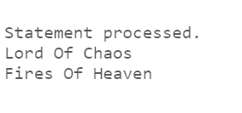

**-- *Procedure 8* --**

**-- Get student details from book id**

CREATE OR REPLACE PROCEDURE student_details(book_id IN NUMBER) IS

roll_no subscription.rollno%TYPE;

n_ame student.name%TYPE;

mobile_num student.m_no%TYPE;

f_ine student.fine%TYPE;

books_issued student.issued_books%TYPE;

BEGIN

SELECT s.rollno

INTO roll_no

FROM subscription s

WHERE s.bookid = book_id;

SELECT st.name, st.m_no, st.fine, st.issued_books

INTO n_ame, mobile_num, f_ine, books_issued

FROM student st

WHERE st.rollno = roll_no;

dbms_output.put_line('Name : '||n_ame);

dbms_output.put_line('Mobile Number : '||mobile_num);

dbms_output.put_line('Fine : '||f_ine);

dbms_output.put_line('Number of books issued : '||books_issued);

END;

DECLARE

book_id number;

BEGIN

dbms_output.put_line('Enter the book id of the book');

book_id:=5;

student_details(book_id);

END;

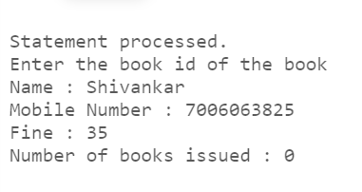 // Here info. Of user related to that book id came . the fine here is Rs. 35 which can be paid using procedure 5.

**THE END**

<https://github.com/Shivankar1710/DBMS_PROJECT/tree/main/PROJECT_DBMS>